Vattenfall

Description Matlab Model for
Biogas Flex

by

KYOS Energy Consulting B.V.

24 March 2014

Hans van Dijken, vandijken@kyos.com
tel +31 23 5510221

Table of contents
Table of contents 2
Introduction 3
Purpose of this document 3
General information about Biogas Flex 3
Installation of the software 5
Process flow 5
Installing the Matlab component runtime (MCRInstaller) 5
Installing solver lp solve 5
Defining the inputs 6
Defining CHP inputs in xls input file 6
General inputs 6
Inputs CHPS 7
Other inputs 8
Inputs for prices and heat 9
Running the Matlab Model 10
Matlab User Interface 10
Storing results 11
Uploading results in output spreadsheets 11
Uploading results on hourly basis 11
Uploading hourly results for imbalance calculation 12
Importing aggregated results 12
Mathematical optimization 13
Set-up of Matlab model 13
Mathematical constraints 13
Optimization goal function 14
Remarks 15
Imbalance calculation 15
Prices and heat demand – length input files 15
Infeasible solution 15

Introduction

Purpose of this document
This document describes how the Biogas Flex model can be used, and what mathematical assumptions are used.

General information about Biogas Flex
On a high level, the optimization problem is visualized in Figure 1.
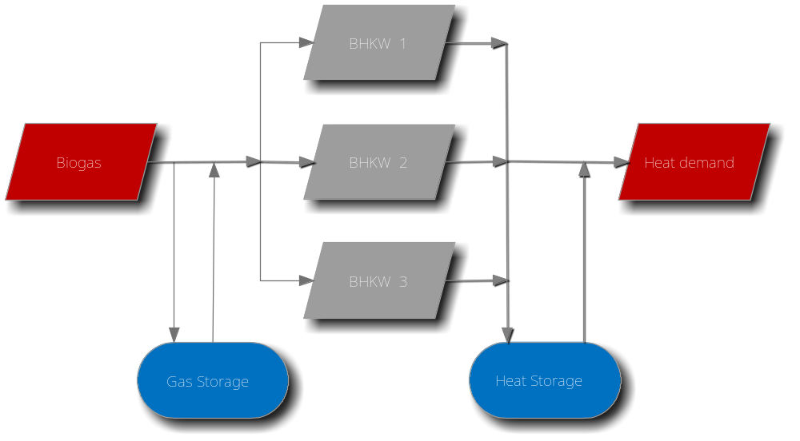
Figure 1, Description Biogas Flex optimization
There is a baseload production of Biogas. The Biogas can (i) be stored in a gas storage or (ii) be used in a CHP. The storage has a limited size, meaning that when the gas storage is full, 1 or more CHP’s are forced to run.
Each CHP has limitations in (i) capacity, (ii) efficiency, (iii) allowed number of starts per day and (iv) maximum power production per calendar year. There is a minimum of 1 CHP, and a maximum of 3 CHP’s.
All three CHP’s produce heat. The heat of 1 or more CHP’s can be used to fulfil a heat demand. The heat can also be stored in a heat storage. In any case, the minimum heat production/supply is equal to the hourly demand.
The CHP’s also produce electricity. The income is defined as the difference between the hourly power price and the monthly average power price. This reflects the extra income which can be generated on top of the baseload power price. Or to phrase differently, this is the income based on day-ahead optimization.
The optimization is set up to maximize income, while at the same time fulfilling all physical constraints.

Installation of the software

Process flow
The Biogas Flex model is developed in Matlab. It can run within Matlab, or as an executable. In both cases, the user provides the inputs in Excel files. Results are saved in xlsx (Excel 2007) files, and then uploaded to one or more Excel output files.
To run the Biogas Flex model without Matlab, 2 programs need to be installed:
- Matlab Compiler Runtime
- LP Solve

Installing the Matlab component runtime (MCRInstaller)
This step is only needed if the model is used as an executable, outside of Matlab.
Matlab Compiler Runtime is a free program, necessary to run compiled Matlab models. The program depends on the operating system (Windows, Linux) and hardware configuration (32 bit, 64 bit). Based on the desktop/server configuration, KYOS will provide the appropriate version of Matlab Compiler Runtime.
- Save the file MCRInstaller.exe on your computer;
- Execute this program and go through the installation wizard. This program is needed to run compiled Matlab code on your computer and is about 150 MB.

Installing solver lp solve
The Biogas Flex model uses linear programming (LP) techniques to calculate the expected value. The free solver LP Solve is used to execute LP-based subroutines of Biogas Flex on a local computer or network.
LP Solve is a free linear (integer) programming solver based on the revised simplex method and the Branch-and-bound method for the integers (see also http://lpsolve.sourceforge.net/5.5/). The version you need depends on the type of computer (32-bit or 64-bit). In any case, some lp-solve files need to be copied into a Windows directory or into the directory where the model is run. Please refer to the lp-solve website or ask KYOS for assistance

Defining the inputs

Defining CHP inputs in xls input file
The inputs need to be defined in a pre-formatted spreadsheet.

General inputs
In general inputs, inputs can be provided for the valuation period and the optimization method. There are 3 optimization methods implemented:
- Monthly average
The optimization is performed between hourly EEX power prices and the monthly average EEX power price. When possible, the CHP should run in those hours where the hourly EEX price is higher than the monthly average power price.
The income is calculated as the difference between the hourly EEX price minus the monthly average EEX price.
Gas costs are assumed to be zero. Variable O&M costs are not taken into account. The reason is that the optimization changes the dispatch over the evaluation period. The total power production, and thereby the total O&M costs, are assumed to be constant under various dispatch scenarios.
- Daily average
The optimization is performed between hourly EEX power prices and the daily average EEX power price. When possible, the CHP should run in those hours where the hourly EEX price is higher than the daily average power price.
The income is calculated as the difference between the hourly EEX price minus the monthly average EEX price.
Gas costs are assumed to be zero. Variable O&M is not taken into account.
- Market
This is the traditional valuation, where income is defined as the difference between power income and costs O&M. Gas costs are assumed to be zero.
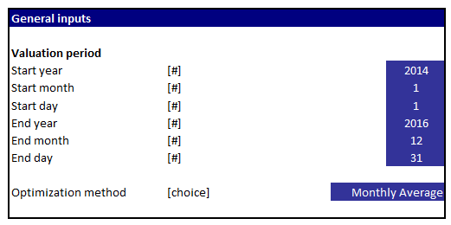
Figure 2, General inputs

Inputs CHPS
The following inputs can be defined for 1 to 3 CHP’s.
- Capacity: the maximum electric capacity, defined in kW
- Heat: the maximum heat supply, defined in kW
- Efficiency: the efficiency when running on maximum efficiency
- Minimum Capacity: the minimum capacity the power plant has to produce when it is in production. The inputs are defined in kW
- Variable costs for O&M
- Max starts per day: the maximum number of starts the CHP is allowed to make per calendar day
- Max fulload hours per year: the maximum number of full loads hours the CHP is allowed to produce. E.g.: a restriction of 7,200 hours, given a capacity of 400 kW, leads to a maximum allowed production of 2,880 MWh (= 7,200 * 400 / 1,000).
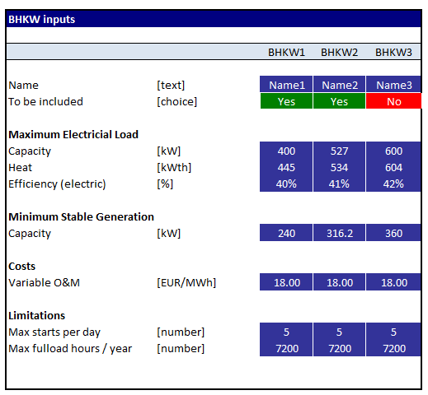
Figure 3, Inputs BHKW

Other inputs
The remaining inputs are:
- Biogas production, defined as a baseload supply in kWth per hour
Inputs for the gas storage
- The minimum volume
- The maximum volume
- The injection costs, defined as EUR / MWh
Inputs for the heat storage
- The minimum volume
- The maximum volume
- The heat loss, defined as % per hour
Inputs for heat supply
- The user can define if BHKW1, or all CHP’s will supply the heat
Imbalance markets
- Reserved capacity for long imbalance market. For the optimization, this leads to a reduced maximum capacity, meaning there is always the possibility to ramp up. Furthermore, the plant has to produce each individual hour at least the minimum production.
- Reserved capacity for long imbalance market. For the optimization, this leads to an increased minimum capacity. The consequence is the power plant has to run each hour, and there is the possibility to ramp down to the normal minimum load.
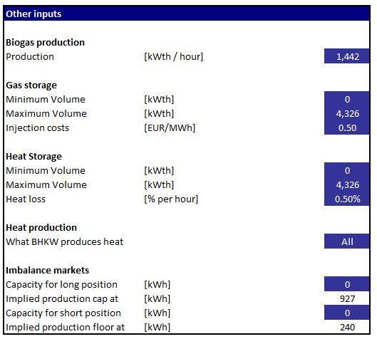
Figure 4, Other inputs

Inputs for prices and heat
The inputs for hourly heat demand and power prices need to be stored in a pre defined format. Power prices need to be stored in the file PowerPrices.xls. The format is aligned with the format of LTMO prices. The hourly heat demand needs to be stored in the file HeatDemand.xls.
Both the power and the heat input files need to be stored in the same directory.

Running the Matlab Model

Matlab User Interface
When the Matlab model is opened, a small user interface appears. The user should fill in:
- Where the xls input file is stored, and under what name
- In what directory the prices and heat demand are stored
- In what directory the output files should be stored
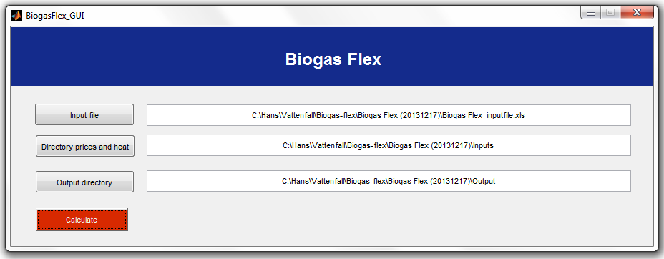
Figure 5, User interface to run Biogas model
When the button ‘Calculate’ is pressed, the model starts to calculate. An optimization is done per day. On the screen a message appears showing the progress. When the model is finished, the message appears ‘Write outputs to Excel’ and ‘Elapsed time is …’.
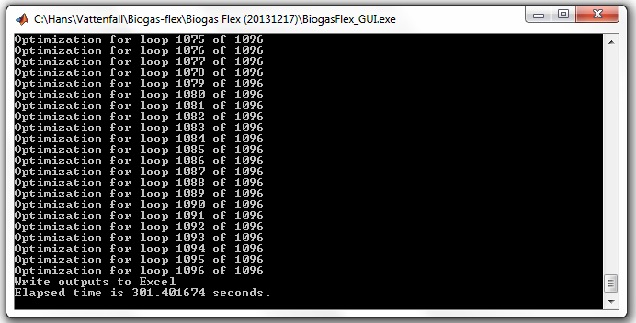
Figure 6, User screen when running the model as executable, showing the progress

Storing results
When the Matlab calculation is finished, the message ‘Elapsed time is ….. seconds ‘ appears on the screen. All results are stored in the user defined directory.
The output files have pre-defined names, and all files are produced in Excel 2007 (.xlsx) format. The reason is that hourly outputs for 10 years are stored on almost 90.000 rows (8760 * 10), and this size is not accepted by earlier versions of Excel.
Matlab will first check if Excel files from previous runs are already stored in the same directory. In case 1 or more files are found, they are automatically (i) closed and (ii) deleted from the directory. This ensures that all outputs in the same directory will be from the same calculation run, and results can not be mixed.

Uploading results in output spreadsheets

Uploading results on hourly basis
Results can be uploaded in an Excel file. There are 2 macro’s included in the spreadsheet:
- A Microsoft VBA macro which clears all previous results. The user can see the spreadsheet is completely empty, and all previous values are gone
- A Microsoft VBA macro which imports all outputs. When the user pushes this button, he has to select the directory in which the results are stored.
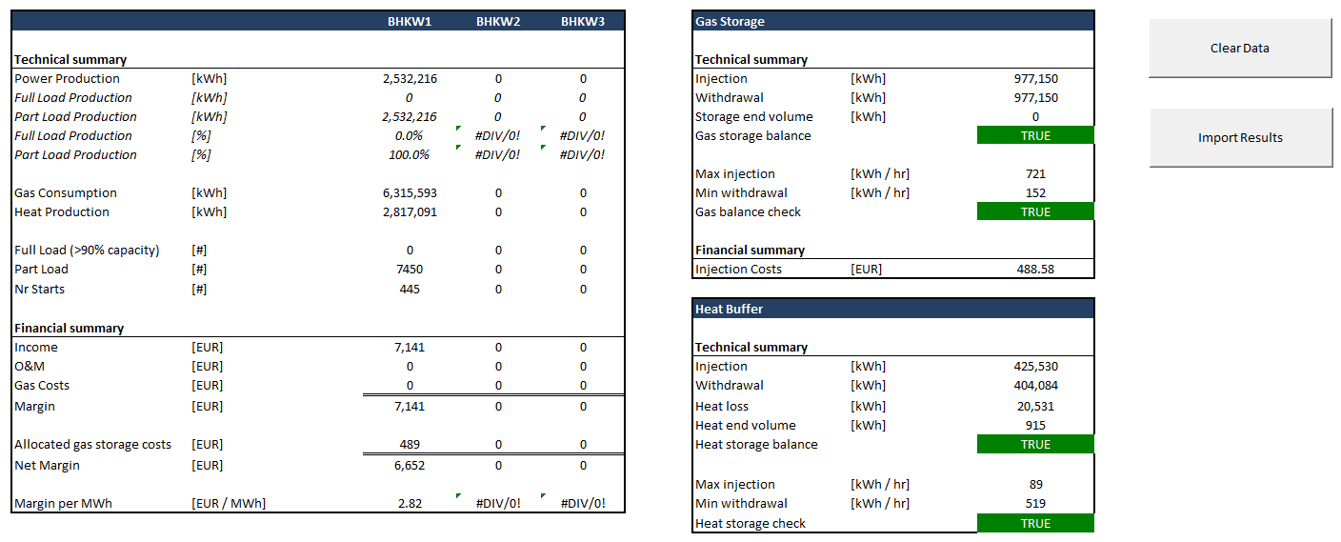
Figure 7, Uploading results on hourly basis
On the summary page, the following checks are performed:
- Gas storage balance: a check that the total injected gas equals the total withdrawn gas (there is no gas loss)
- Gas balance check: for each individual hour, the total supply of Biogas plus the gas withdrawn from the storage equals the gas which is injected in the storage or taken by the CHP’s.
- Heat storage balance: a check that the total injected heat equals the total withdrawn heat plus the heat loss (there is no heat loss)
- Heat storage check: for each individual hour, the total supply of heat plus heat withdrawn from the storage is larger or equal to the heat demand and the heat injected to the storage.
There is a second tab called ‘Detailed Outputs’, which shows per hour:
- Heat demand and Biogas production
- Power production, gas consumption and heat production per CHP
- Statistics per CHP: starts and full load hours
- Statistics for the gas storage: injection, withdrawal, storage level and injection costs
- Statistics for the heat storage: injection, withdrawal, storage level and heat loss in the storage
- Statistics for the P&L: power prices, average monthly power prices, costs O&M and income per CHP. The P&L reflects the margin that can be made on top of baseload power production.

Uploading hourly results for imbalance calculation
The user can also select to import results for the imbalance calculation. The procedure is almost identical. The user pushes the button ‘Import Results’. Thereafter he has to select the directory in which the results are stored. The only difference is the user has to mark the checkbox ‘Imbalance Run’, as shown in below figure.
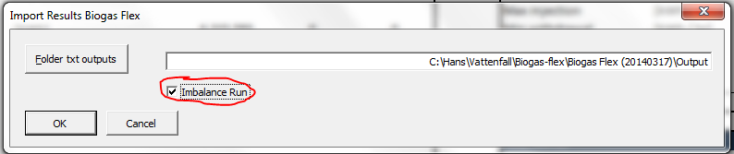
Figure 8, Import results for the imbalance calculation

Importing aggregated results
There is a second spreadsheet which can import aggregated results. The logic is the same: (i) the user presses the VBA button to clear previous results, (ii) the user presses the button to import results and (iii) the user selects the folder in which the results are stored.
The format of the results and the presentation of various values are discussed with the Biogas project management. However, the outputs from the hourly files contain all relevant information, and should form the basis of any further processing.

Mathematical optimization

Set-up of Matlab model
The Biogas flex model has to find an optimal solution for running 3 power stations, using a gas storage and using a heat buffer. In each individual hour, all technical constraints of all assets must be taken into account. The optimization is found by using linear programming techniques. When more constraints where added in the optimization, the performance reduced substantially. Furthermore the model assumes that at the end of the valuation period, the heat and gas storage are empty (or they can have any other arbitrary fixed number). This assumption is not in line with reality.
Because of (i) performance problems and (ii) the limitation of a pre-defined end level, a solution was proposed by optimizing over a 2 day horizon (= 48 hours). From these 48 hours, only the first 24 hours were used. The end level of hour 24 was used as start point for the next calculation run. This ensured the heat and gas storage did not have to be empty at the end of the day.
When an optimization is performed over 1 year, 365 calculations are performed over a period of 2 days. The first calculation run is for day 1 & 2, the second calculation day is for day 2 & 3, the third calculation day is for day 3 & 4, etc.

Mathematical constraints
The mathematical constraints can be explained with below visualisation.
Figure 9, Overview Biogas Flex

Constraints CHP
- The CHP can have a maximum number of starts per day
- The CHP is forced to run between minload and maxload
- The maximum production of the CHP over the 2 day valuation period is smaller than the allowed level. The allowed 2 day level is defined as the 2 * 24 * maximum capacity * full load hours per year / 8760

Constraints Biogas
- (The Biogas production + Gas withdrawn from the storage) = (Biogas consumed by CHP’s + Biogas injected in storage)
- The Biogas in the gas storage at the beginning of the optimization equals the level on hour 24 of the previous calculation run.
- The Biogas in the gas storage at the end of the optimization (end of the second day) has to be zero

Constraints Heat Buffer
- (The heat production + Heat withdrawn from storage) >= (Heat demand + Heat injected in storage + Heat loss)
- The heat in the heat storage at the beginning of the optimization equals the level on hour 24 of the previous calculation run.
- The heat in the heat storage at the end of the optimization (end of the second day) has to be zero

Constraints Imbalance calculation
- Offer to increase production:
  - The maximum production per hour is the sum of the capacities of all CHP’s, minus the capacity which is offered on the market
  - The minimum production per hour is the minimum capacity of all CHP’s, plus the capacity which is offered on the market
- Offer to decrease production:
  - The minimum production per hour is the minimum capacity of all CHP’s, plus the capacity which is offered on the market

Optimization goal function
The goal function is to maximize income. All constraints must be fulfilled. Discounting is not incorporated.

Remarks

Imbalance calculation
A calculation for an imbalance run is done automatically when an imbalance position is filled in.

Prices and heat demand – length input files
In each calculation run the model optimizes for 2 days. Therefore there need to be prices and a heat demand defined at least up to 1 day after the valuation period.

Infeasible solution
Sometimes a solution may not be feasible. In this case, a message box will appear and it will mention a solution could not be found in a certain loop.
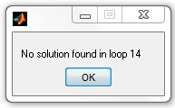
Figure 10, Matlab can not find a feasible solution

